H.T No
Regulations:
A17

Sreenidhi Institute of Science and Technology
(An Autonomous Institution)
Code No: 6K402 Date: 13-Nov-2020 (FN)

B.Tech II-Year II-Semester External Examination, Nov/Dec - 2020 (Supplementary)
STRUCTURAL ANALYSIS-I (CIVIL)

Time: 2 Hours Max.Marks:75

Note: a) No additional answer sheets will be provided.
b) All sub-parts of a question must be answered at one place only, otherwise it will not be valued.
c) Missing data can be assumed suitably.

ANSWER ANY 5 OUT OF 8 QUESTIONS. EACH QUESTION CARRIES 15 MARKS.

1. | a) | A plane frame ABCDEFGH shown in figure has a fixed support at A, hinge supports at G and H, axial force release at C and moment release (hinge) at E. The static (d_{s}) and kinetic (d_{k}) indeterminacies respectively are  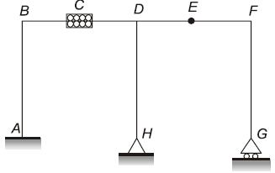 | [8M]
 | b) | Determine the degrees of freedom of the following frame.  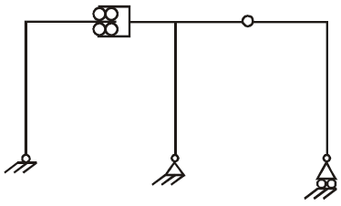 | [7M]
2. | a) | Using the method of joints, find the axial forces in all the members of a truss with the loading shown in Figure below.  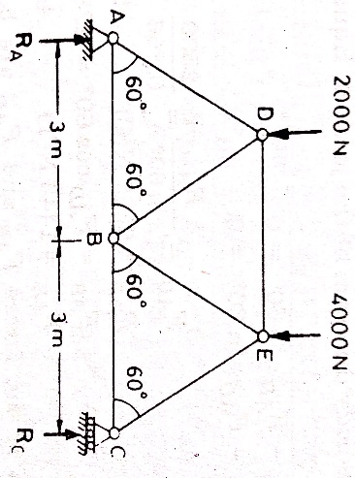 | [8M]
 | b) | The force in the member DE of the truss shown in the Figure is  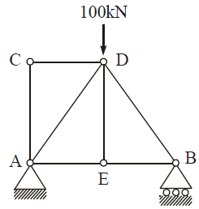 | [7M]
3. | a) | Analyze two span continuous beam ABC by slope deflection method. Then draw Bending moment & Shear force diagram. Take EI constant  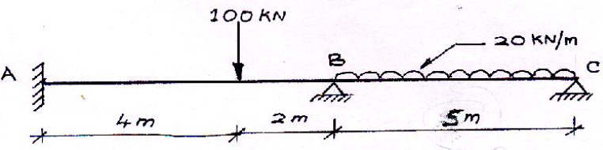 | [10M]
 | b) | Write the steps for analysis of structures by using slope deflection method. | [5M]
4. | a) | Analyse the beam shown in Figure below by moment distribution method. Draw the SFD and BMD.  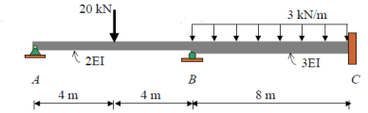 | [10M]
 | b) | Explain about carry over factor in moment distribution method. | [5M]
5. | a) | Analyse the frame shown in Figure below by Kani's method  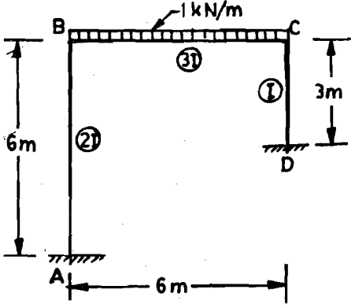 | [10M]
 | b) | Explain about rotation factor in Kani’s method. | [5M]
6. | a) | Draw the shear force and bending moment diagrams for propped cantilever having central point load with magnitude of P = 40 kN. Take L = 10 m.  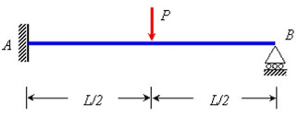 | [10M]
 | b) | Write the disadvantages of a fixed beam? | [5M]
7. | a) | Explain static indeterminacy in beams. | [6M]
 | b) | Determine the force in each member of the truss and state whether the force is tension or compression  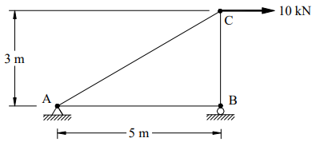 | [9M]
8. | a) | Explain about the carry over moment in moment distribution method. | [8M]
 | b) | Explain about displacement factor in Kani’s method. | [7M]
-- 00 -- 00 –

